*ASSIGNMENT 8*

***//Q1 - Form***

<body>

    <h1>Personal Details</h1>

    <form *action*="./display.php" *method*="post">

        Name: <input *type*="text" *id*="name" *name*="name"><br><br>

        Email: <input *type*="email" *id*="email" *name*="email"><br><br>

        Courses:

        <select *name*="course" *id*="course">

            <option *value*="btech">BTech</option>

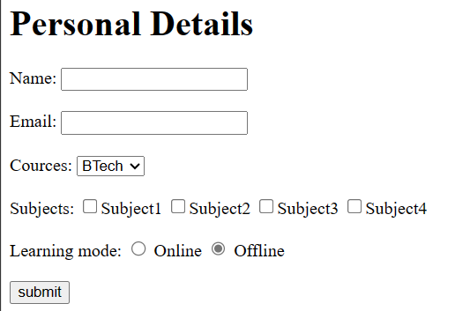            <option *value*="mtech">MTech</option>

            <option *value*="bca">BCA</option>

            <option *value*="mca">MCA</option>

        </select>

        <br><br>

        Subjects:

        <input *type*="checkbox" *name*="c1">Subject1

        <input *type*="checkbox" *name*="c2">Subject2

        <input *type*="checkbox" *name*="c3">Subject3

        <input *type*="checkbox" *name*="c4">Subject4

        <br><br>

        Learning mode:

        <input *type*="radio" *id*="online" *name*="mode" *value*="online"> Online

        <input *type*="radio" *id*="offline" *name*="mode" *value*="offline" *checked*> Offline

        <br><br>

        <input *type*="submit" *value*="submit" *name*="submit">

    </form>

</body>

//display.php

<?php

        echo "Name: "*.*$_POST['name'];

        echo "<br>Email: "*.*$_POST['email'];

        echo "<br>Course: "*.*$_POST['course'];

*if*(get('c1') *||* get('c2') *||* get('c3') *||* get('c4'))

            echo "<br>Courses: ";

*if*(get('c1'))

            echo 'Subject1, ';

*if*(get('c2'))

            echo 'Subject2, ';

*if*(get('c3'))

            echo 'Subject3, ';

*if*(get('c4'))

            echo 'Subject4';

        echo "<br>Learning mode: "*.*$_POST['mode'];

        function get($v) {

*return* isset($_POST[$v]);

        }

?>

***//Q2 – Calculate Simple Interest***

<body>

    <h1>Personal Details</h1>

    <form *action*="./display.php" *method*="post">

        Principle: <input *type*="number" *name*="p"><br><br>

        Rate: <input *type*="number" *name*="r"><br><br>

        Time: <input *type*="number" *id*="online" *name*="t">

        <br><br>

        <input *type*="submit" *value*="submit" *name*="submit">

    </form>

</body>

//display.php

<?php

        echo "Principle: "*.*($p *=* $_POST['p']);

        echo "<br>Rate: "*.*($r *=* $_POST['r']);

        echo "<br>Time: "*.*($t *=* $_POST['t']);

        echo "<br>Simple Interest: "*.* $p *\** $r *\** $t */* 100;

?>

***//Q3 – Guessing Game***

<form *action*="index.php" *method*="post">

        Your guess: <input *type*="number" *name*="guess"><br>

        <input *type*="submit" *value*="Submit" *name*="submit">

</form>

<?php

*if*(isset($_POST['submit'])) {

            $rn *=* floor(rand(1, 5));

            $guess *=* $_POST['guess'];

*if*($rn *==* $guess) {

                echo "Correct!";

            } *elseif* ($rn *<* $guess) {

                echo "Too low!";

            } *else* {

                echo "Too high!";

            }

        }

?>

***//Q4 – Login after authentication***

<body>

    <h1>Login</h1>

    <form *action*="./login.php" *method*="post">

        Enter ID: <input *type*="text" *id*="name" *name*="id"><br><br>

        Password: <input *type*="password" *id*="email" *name*="pass">

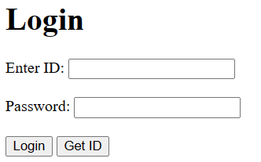        <br><br>

        <input *type*="submit" *value*="Login" *name*="login">

        <input *type*="submit" *value*="Get ID" *name*="show">

    </form>

</body>

//login.php

<?php

        $keys *=* array('U1' *=>* '123', 'U2' *=>* '456', 'U3' *=>* '789', 'U4' *=>* '5478');

*if* (isset($_POST['login'])) {

            $id *=* $_POST['id'];

            $pass *=* $_POST['pass'];

*if*(array_key_exists($id, $keys) *&&* $keys[$id] *==* $pass) {

                echo "<h1>Login Success!</h1>";

*return*;

            }

            echo "No user found!";

        } *else* {

            echo "<table border=1>";

            echo "<tr><th>ID</th><th>Password</th></tr>";

*foreach* ($keys *as* $id *=>* $pass) {

                echo "<tr><td>"*.*$id*.*"</td>";

                echo "<td>"*.*$pass*.*"</td></tr>";

            }

            echo "</table>";

        }

?>

***//Q5 – Form processing using HTML***

<body>

    <style>

        sup {color: red;}

    </style>

    <h1>Personal Details</h1>

    <form *action*="./display.php" *method*="post">

        <label *for*="fname">First name: </label>

        <input *type*="text" *id*="fname" *name*="fname" *required*><sup>*</sup><br><br>

        <label *for*="lname">Last name: </label>

        <input *type*="text" *id*="lname" *name*="lname" *required*><sup>*</sup><br><br>

        <label *for*="address">Address: </label>

        <input *type*="text" *id*="address" *name*="address" *required*><sup>*</sup><br><br>

        <label *for*="email">Email: </label>

        <input *type*="email" *id*="email" *name*="email" *required*><sup>*</sup><br><br>

        <label *for*="password">Password: </label>

        <input *type*="password" *id*="password" *name*="pass" *required*><sup>*</sup><br><br>

        Gender:

        <input *type*="radio" *id*="male" *name*="gender" *value*="Male">

        <label *for*="male">Male</label>

        <input *type*="radio" *id*="female" *name*="gender" *value*="Female">

        <label *for*="female">Female</label>

        <br><br>

        <input *type*="submit" *value*="Submit" *name*="submit">

    </form>

</body>

//display.php

<?php

        echo "<table border=1>";

        echo "<tr><th>Parameter</th><th>Value</th></tr>";

        echo "<tr><td>First name</td><td>"*.*$_POST['fname']*.*"</td>";

        echo "<tr><td>Last name</td><td>"*.*$_POST['lname']*.*"</td>";

        echo "<tr><td>Address</td><td>"*.*$_POST['address']*.*"</td>";

        echo "<tr><td>Email</td><td>"*.*$_POST['email']*.*"</td>";

        echo "<tr><td>Password</td><td>"*.*$_POST['pass']*.*"</td>";

        echo "<tr><td>Gender</td><td>"*.*$_POST['gender']*.*"</td>";

        echo "</table>";

?>

